**Practical4:Excel Automation**

**4a. Automate the process to extract data from an excel file into a data table and vice versa.**

Step 1 : Create an excel file with name StudentDetails.xlsx with following data.

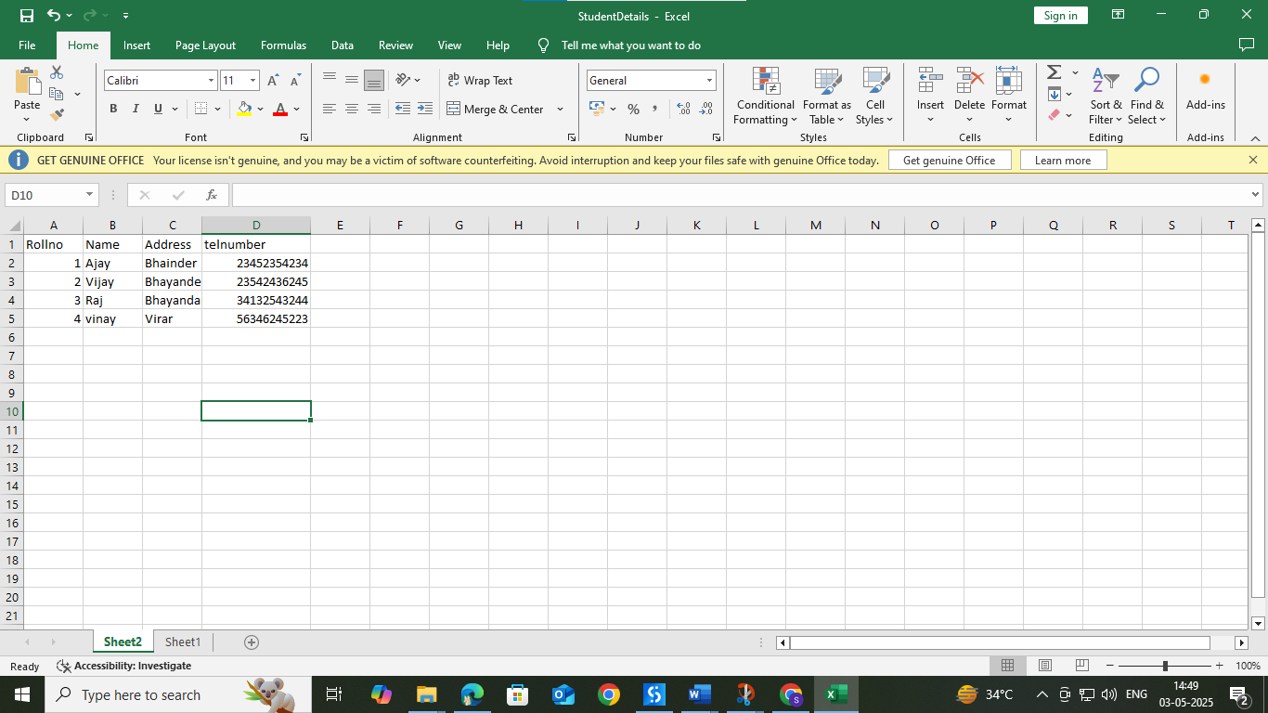

Step 2: Open UI path and create new project with appropriate name and choose language type VB.

Step 3 : Select Excel Application Scope from the activity window and drop into sequence and insert the path of the StudentDetails.xlsx file.

Step 4 : : Select Do activity from the activity window and drop into sequence and then select Read Range from the activity window and give “sheet1” as read range input.

Step 5 : Select For Each Row in Data Table activity from the activity window and drop into sequence and give inputs as shown below.

Step 6 : Select Write Range activity from the activity window and drop into sequence to specify the sheet where we need to copy the data and give inputs as shown below. Here sheet2 is given as input for the data to be copied from sheet1.

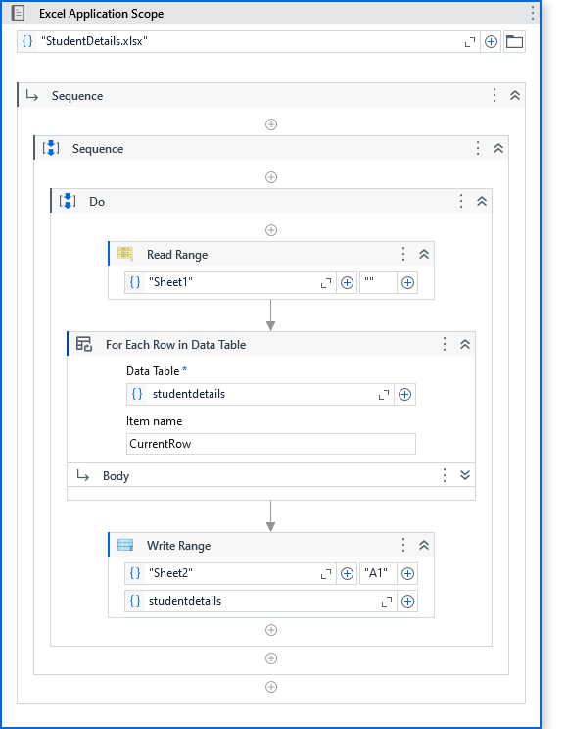

**O/P :**

Here data from Sheet2 is copied to Sheet1

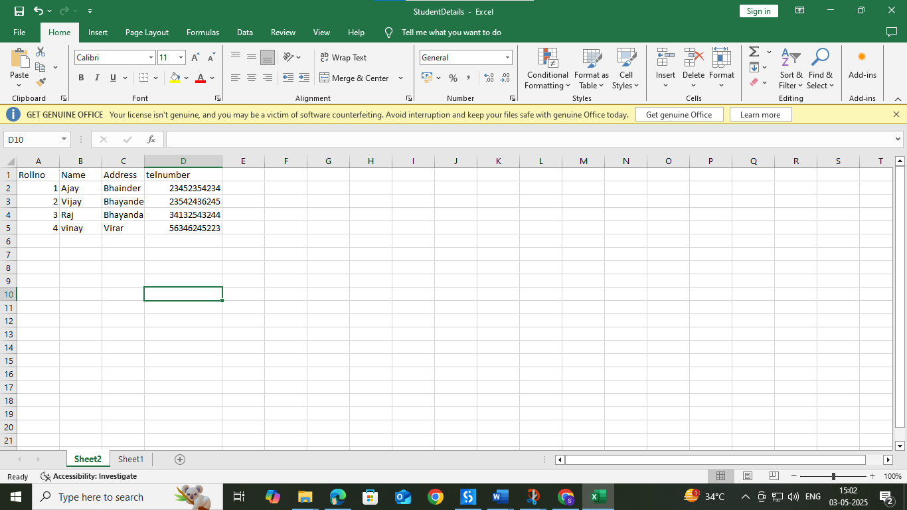

**4b. Create an automation to Write data to specific cell of an excel sheet.**

Step 1 : Create an empty excel file StudentDetails.xlsx.

Step 2 : Step 2: Open UI path and create new project with appropriate name and choose language type VB.

Step 3 : Select Excel Process Scope from the activity window and drop into sequence

Step 4 : Select Do activity from the activity window and then select Use Excel File activity and give inputs as below. Insert StudentDetails.xlsx as excel input.

Step 5 : Again select Do activity from the activity box and insert write cell activity to specify the data to be written in specific cell and give input as below along with the cell location

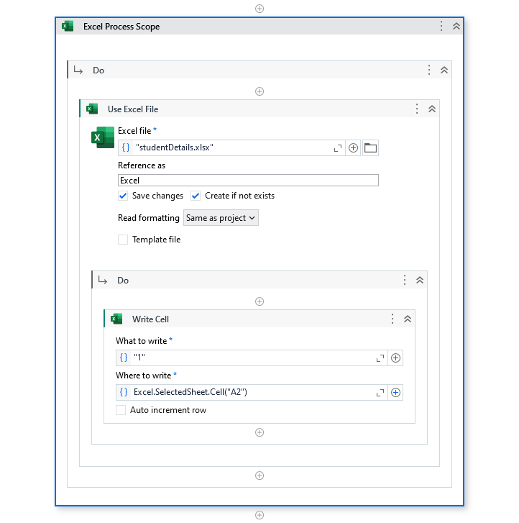

**O/P :**

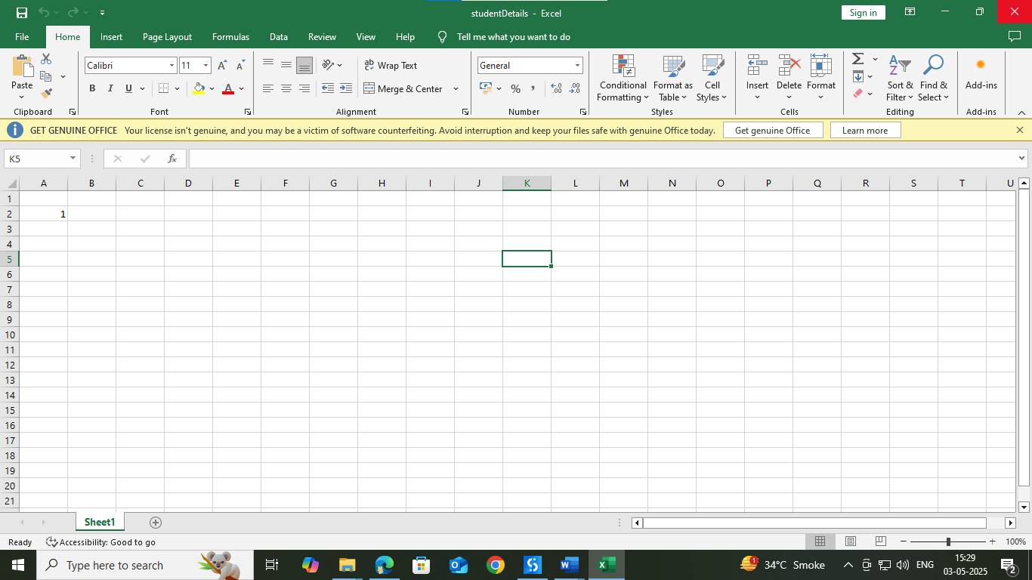

**4c. Create an automation to Read data to specific cell of an excel sheet.**

Step 1 : Create an excel file with name StudentDetails.xlsx with following data.

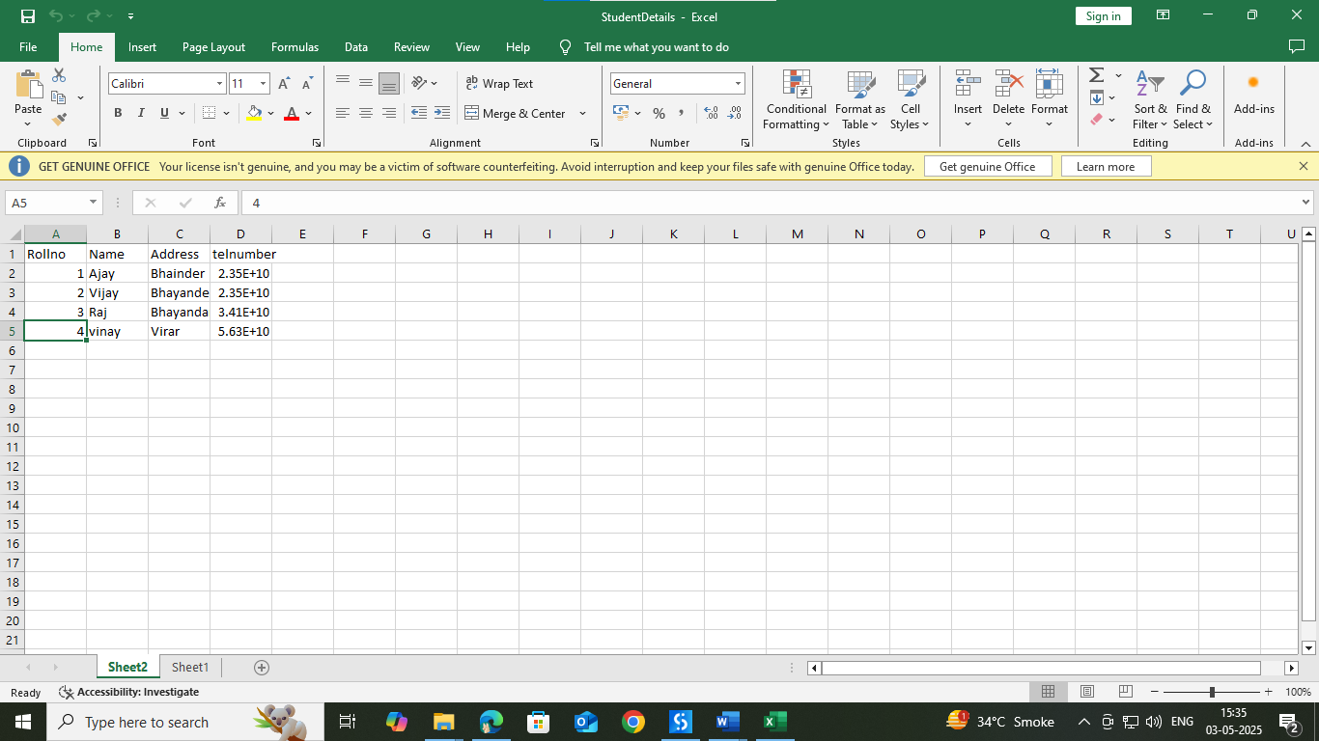

Step 2 : Step 2: Open UI path and create new project with appropriate name and choose language type VB.

Step 3 : Select Excel Process Scope from the activity window and drop into sequence

Step 4 : Select Do activity from the activity window and then select Use Excel File activity and give inputs as below. Insert StudentDetails.xlsx as excel input.

Step 5 : Again select Do activity from the activity box and insert read cell activity to read the data from the specified location. Use input values as shown below to read the data

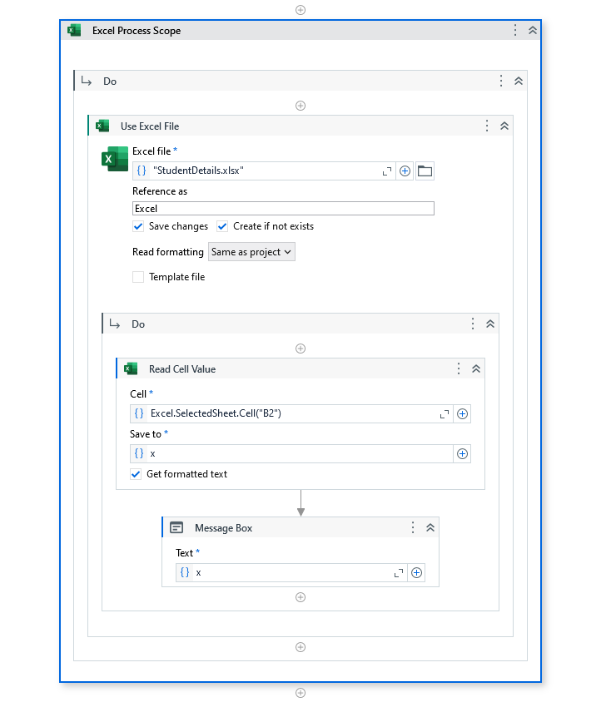

**O/P :**

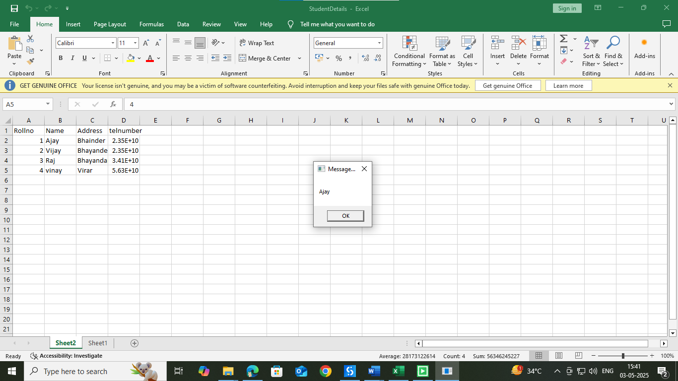

**4d. Create an automation to append data to specific cell of an excel sheet.**

Step 1 : Create an empty excel file StudentDetails.xlsx.

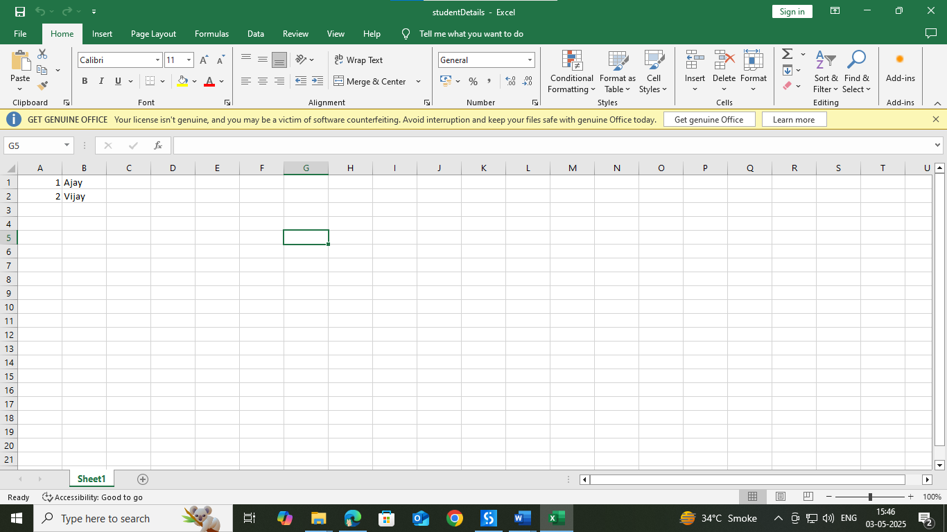

Step 2 : Step 2: Open UI path and create new project with appropriate name and choose language type VB.

Step 3 : Select Excel Process Scope from the activity window and drop into sequence

Step 4 : Select Do activity from the activity window and then select Use Excel File activity and give inputs as below. Insert StudentDetails.xlsx as excel input.

Step 5 : Again select Do activity from the activity box and insert Build data table and then insert append range . Use input values as shown below to read the data

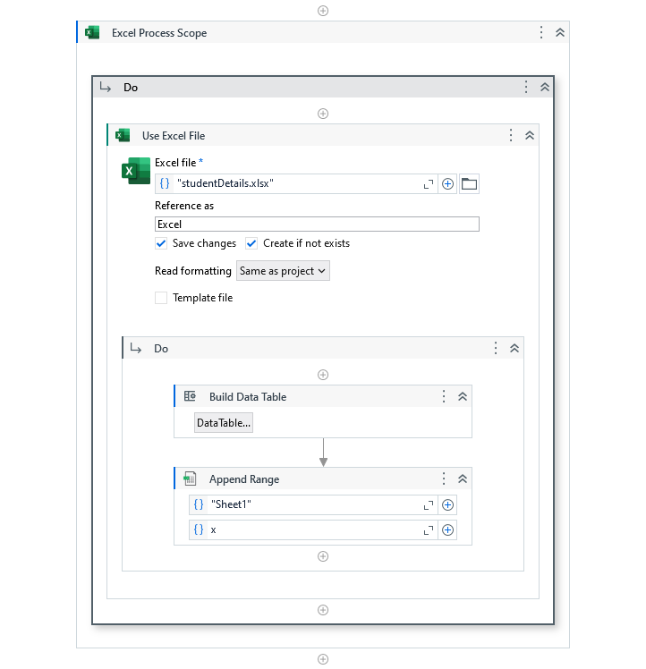

**o/p:**

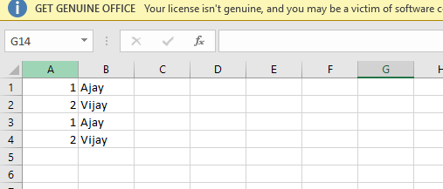

**4e. Create an automation to sort a table of an excel sheet.**

Step 1 : Create an excel file Student.xlsx.

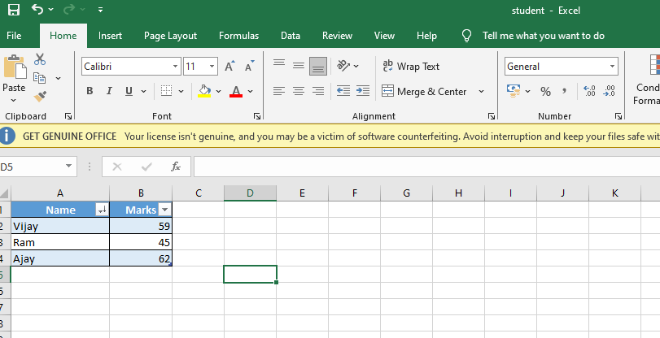

Step 2 : Step 2: Open UI path and create new project with appropriate name and choose language type VB.

Step 3 : Select Excel Process Scope from the activity window and drop into sequence

Step 4 : Select Do activity from the activity window and then select Use Excel File activity and give inputs as below. Insert Student.xlsx as excel input.

Step 5 : Again select Do activity from the activity box and insert Sort Table to sort the data . Use input values as shown below to read the data

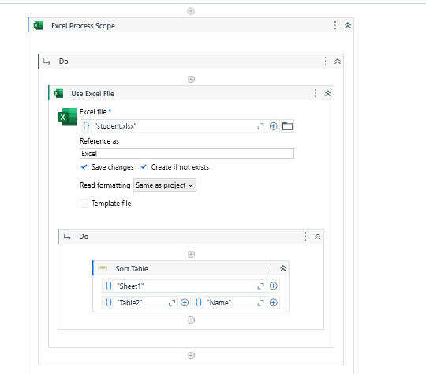

**o/p:**

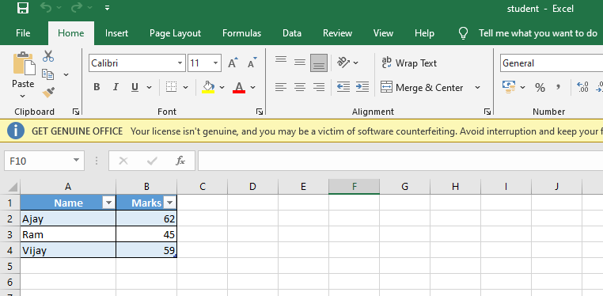

**4f: Create an automation to filter a table of an excel sheet**

Step 1 : Create an excel file Student.xlsx.

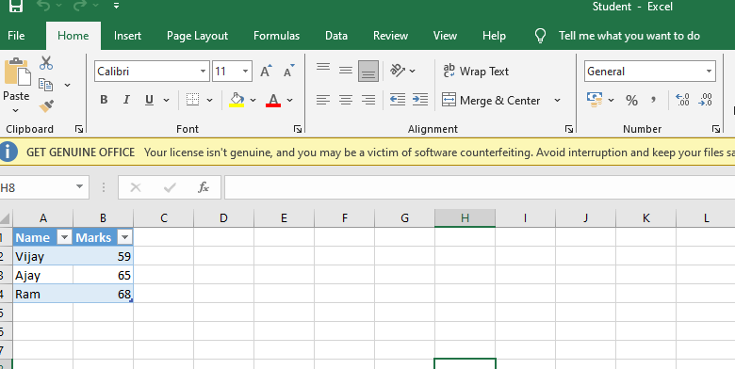

Step 2 : Step 2: Open UI path and create new project with appropriate name and choose language type VB.

Step 3 : Select Excel Process Scope from the activity window and drop into sequence

Step 4 : Select Do activity from the activity window and then select Use Excel File activity and give inputs as below. Insert Student.xlsx as excel input.

Step 5 : Again select Do activity from the activity box and insert Filter Table to filter the data . Use input values as shown below to read the data

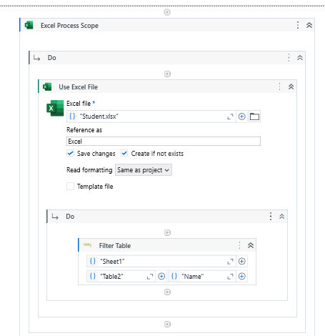

**o/p**

